**JavaScript – Change Textures**

Set of tests to change texture maps, either interactively, or per frame as in a sprite animation.

**JSChgTexture-SimpleDemo.x3d**

A one-time change of both the texture, from blue.jpg to red.jpg, and the Material’s diffuseColor



**JSChgTexture-InteractiveTextureChg.x3d**

Rolling over the numbered box on the left will change the texture map from ‘1’, to ‘2’, etc, to ‘5’, and then back to ‘1’. Clicking on the box to the right will change the texture map from ‘red.jpg’ to ‘green.jpg’ to ‘blue.jpg’ and back to ‘red.jpg’.



**JSChg-Read texture map file name.x3d**

The JavaScript reads the current name of the texture map file and changes to another texture map based on that. So, we begin with ‘red.jpg’, and switch to ‘green.jpg’ if the JavaScript detects the current texture map is ‘red.jpg’. If the current texture map is ‘green.jpg’, the JavaScript switches the texture map to ‘blue.jpg’. And if the texture map is ‘blue.jpg’, upon rollover, the JavaScript switches to ‘red.jpg’.

Images similar to JSChgTexture-SimpleDemo.x3d above.

**JSChg-OneSecPerFrame.x3d**

This is a five second animation. Each second, the JavaScript switches to another texture map with a number, 1 through 5. The sphere to the right rotates around the x-axis but has not texture map change. It just adds a bit of randomness to the demo.

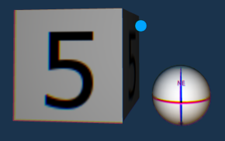

**JSChg-SpriteAnimation.x3d**

This demo is an X3D sprite animation. The looping animation is 1.2 seconds and switches to 30 similarly named texture maps ‘dog_walk_0001.png’ to ‘dog_walk_0030.png’. Note that these texture maps should be in the assets folder and not a subdirectory. As above the rotating sphere is added to randomize the demo and has no texture map changes.

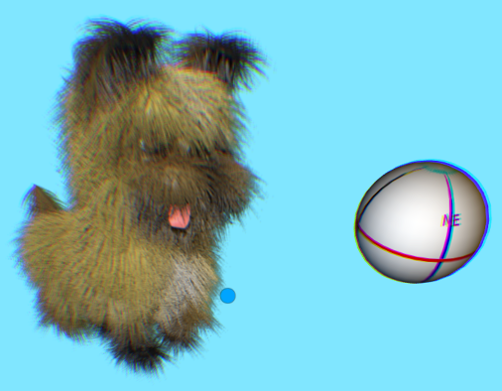

**JSChg-TwoSpriteAnimations.x3d**

Similar to above demo, but includes a second sprite animation, spinning_present.

